**Friends Over Fears**

For as long as Mia could remember, she had been terrified of snakes. She had skipped the class field trip to the zoo, and on the day, James had brought his pet snake into their seventh - grade math class, Mia had run into the hallway, tears pooling in her eyes. With every passing year, Mia’s fear of snakes seemed to be getting worse. Recently, she had started to avoid playing in the local park because sometimes there were small garden snakes in the grass.

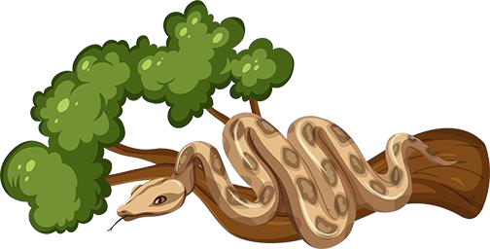

Jess had been Mia’s best friend since kindergarten. Jess wasn’t afraid of snakes or anything else that crawled or slithered. In grade 5, she had hung a huge poster of a boa constrictor on her bedroom wall, but she took it down because it bothered Mia so much. Jess knew all about Mia’s snake phobia, and she used to find it funny, but now it had grown worrisome. I f Mia’s irrational fears kept getting worse, how long would it be before she was afraid to even leave her own house?

One day, Mia went to visit Jess. The new video game, Green Ghosts Gone Wild, had just been released, and Jess had bought it. Mia was stoked. Playing a new game, especially one as epic as Green Ghosts Gone Wild, was a major event. As Mia stepped into Jess’ room, she froze. “What’s that?” Over Jess’s shoulder, she could see a massive glass tank. Judging by its size, it probably wasn’t built for a small creature, and there was no water in the tank, so it wouldn’t contain fish. Logs, leaves, and stones were scattered along the bottom of the aquarium. Suddenly, a scaly tail flashed out from beneath some leaves; Mia jumped and let out a shriek, instantly bounding back into the hallway.

“What’s wrong?” Jess asked, looking both concerned and a little guilty. “Does the snake really bother you that much?” Mia nodded, her eyes darting back and forth between Jess and the distant glass tank. She felt betrayed. How could Jess bring a snake into her house, knowing how Mia felt?

“Tiger is totally contained in the tank, Mia. She can’t escape,” Jess offered weakly. “Come on – I know how badly you want to play Green Ghosts Gone Wild . It’s just a few steps around Tiger’s home to get to my computer.”



“You don’t understand how scary that is for me,” Mia snapped. She felt a hot tear roll down her cheek, and, turning her back on Jess, she stomped out of the house, plopping herself down on the steps outside of Jess’ front door. When she felt Jess’ hand on her shoulder, she shrugged it off, still angry at her friend and contemplating going home where it was safe.

Jess sat down silently beside her friend. A few minutes passed. “I’m sorry for scaring you, Mia,” Jess said, attempting to console her friend. As Mia breathed in the fresh outside air, her panic slowly turned into embarrassment. She gave Jess a weak smile.

She wanted to be playing the game, not fighting with her best friend. She knew the snake couldn’t escape the tank; maybe if she avoided looking at the tank, she could control her emotions while in the room. Mia decided to be brave. “I’m going to try, but don’t let me go anywhere near Tiger.” Jess nodded solemnly and the girls re-entered the house.



Mia stayed close to Jess as they cautiously crept into Jess’s room. Mia purposely stared at the wall opposite the tank as she found her way to Jess’s monitor. “See, that wasn’t so bad, was it?” Jess grinned. Mia scowled; she didn’t agree, but she kept quiet. One look at the slithery reptile was enough to send chills down her spine.

The next day, Mia took her bike over to Jess’ house for another bout of Green Ghosts Gone Wild ; however, her enthusiasm to play the game was mixed in with apprehension about being in the same room as the snake. The closer she got to Jess’ house, the more Mia obsessed about the snake. She was just getting off her bike when Jess’ front door flew open, followed by a small hand waving rapidly in her face.

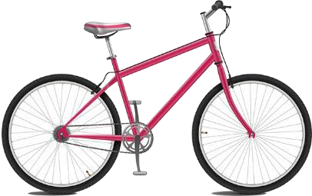

“Hey Mia! Come on in - let’s get started,” Jess shouted excitedly. Mia scowled slightly as she wearily stepped into Jess’ house. Jess could be so insensitive. It was as if she had forgotten about Mia’s fear, or didn’t care at all for her feelings.

Throwing Mia an animated grin, Jess led her friend into the bedroom. Mia glanced uneasily at Tiger’s cage. It took all of her courage, but she managed to make it to Jess’s computer in a few quick leaps.

Mia glared at Jess as she caught her breath. “Can we play the game now? I don’t want to spend any more time thinking about that oversized worm.” Jess laughed, and started the game. The girls played until it was time for Mia to return home. Mia was exhausted, and she yawned sleepily as she got up. “Goodnight, Jess,” she said, before turning her attention for the first time towards the snake on the other side of the room.

Tiger made her way from one side of the aquarium to the other, occasionally lifting her head to let her tongue dart out. Mia didn’t enjoy the sight, but she was mesmerized by how easily she writhed over leaves and around branches. Finally snapping back to reality, Mia decided she had been in Tiger’s presence for far too long.

“Goodnight to you too, I guess,” she mumbled, making her way to the front door and closing it firmly behind her. The girls played the video game every day after school that week. Mia was still bothered by the snake, but at least her stomach wasn’t churning anymore when she thought about it. On Friday, both girls hurried into the computer room to finish the last segment of the game.

“That was so cool,” Jess said as the girls watched the end credits roll off of the screen. “I never expected the Green Ghosts to vaporize the motorcycle gang!”

“Don’t mess with Green Ghosts, I guess,” replied Mia. The girls laughed and sipped their lemonade. Mia felt relaxed and happy. “Close your eyes, I have a surprise for you!” Jess said, jumping up. Mia closed her eyes, rocking back and forth in anticipation.

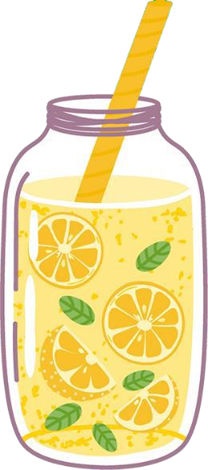

“You can open them now.” When Mia opened her eyes, she wanted nothing more than to close them again. There before her was Tiger, squirming around in Jess’ arms. “Look!” Jess smiled broadly. “She’s very gentle - see how calm she is?”

Mia studied Tiger nervously as she slithered around slowly and curiously. She was almost kind of cute, or at least her face was. Carefully, Jess inquired, “Would you like to hold her?”

Mia’s breath caught in her throat. She wasn’t thrilled by the idea of holding Tiger at all, but Jess’ bright ey es were so enthusiastic that she couldn’t refuse. Mia watched, petrified, as Jess lowered Tiger into her arms. Her hands were shaking, but Tiger didn’t seem to mind. She looked curiously at Mia with bright, beady eyes.

Jess watched Mia carefully and saw how she gradually became less rigid. She told Mia all about Tiger: what type of snake she was, her diet, and more. Meanwhile, Tiger investigated what was in Mia’s pocket, and managed to pull out her bus pass.

“Maybe she wants to take the bus to the zoo and find a boyfriend,” joked Mia as she passed Tiger back to Jess, looking her in the eye.“ To be honest, Jess, I felt betrayed when you bought Tiger because you know how snakes terrify me,” Mia said, in a soft but slightly reproachful voice.

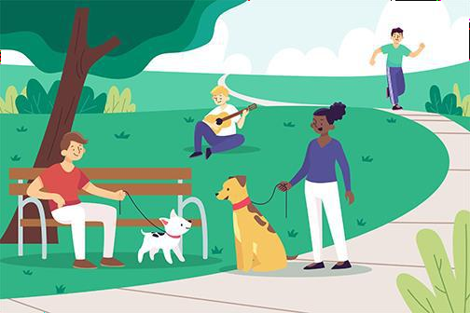

Jess carefully replied. “When you first told me about your fear of snakes, I did everything I could to keep them away from you. Whenever there was an event at school involving snakes, or if someone brought in their pet snake, I would let you know. But when you started to avoid the park, I realized that I wasn’t being a good friend by letting your fears get so out of control. I knew I needed to help you conquer them. So, I started researching snakes, and I searched for the smallest, most harmless one that I could bring home. When I finally chose Tiger, the purchase wasn’t for me. It was for you.”

“Me?” Mia’s eyes darted towards Jess. “I knew you’d be angry with me at first, but after you spent more time in Tiger’s vicinity, you started to get more comfortable. Now look at you two! You’re practically best friends.” As Jess placed Tiger back in her tank, Mia felt a surge of gratitude.

She had misunderstood Jess, assuming that Jess was being selfish when she bought the snake, when in reality she had sacrificed her time and energy to help her. Mia threw her backpack over her shoulder and wrapped her arms around Jess in a big thank you hug.

“Well, we’re best friends, but I’m not sure yet about Tiger.” On her way out, Mia made a detour to say adios to Tiger. When she approached Tiger’s aquarium, she felt no fear. Another high five with Jess, and she was out the door, feeling proud of herself and her friend.

